MAKOL ARIIK DEVELOPMENT FOUNDATION
The Foundation. Makol Ariik Development Foundation (MADF) is a Utah non-profit corporation providing fellowships to graduate students from the semi-autonomous region of Southern Sudan, Africa. MADF received its tax ruling from IRS as a qualified 501c3 organization on September 4, 2007. MADF also holds a Utah charitable solicitation permit issued by the Utah Department of Consumer Protection, reference number 6800786-CHAR.
Initial Project Development. During 2007 and 2008 the Trustees and legal counsel of the Foundation did project development for a program to sponsor deserving college graduates of Southern Sudan to obtain advanced degrees at universities in Africa or the United States. Among other things, the following activities were completed:
- the Foundation President, Mawien Arik, who holder advanced degrees from Cairo University and the University of Utah travelled to Sudan and met with Education ministers and college presidents to determine interest in the project.
- In December, 2007, the Foundation’s legal counsel travelled to Juba, Sudan and met with the Deputy Secretary of Juba University who expressed keen interest in the project. The Secretary noted that Southern Sudan is working diligently to develop a western-style education system and is looking for native students with higher education to teach at its developing universities.
- During 2008, August Mayai, a Trustee of the Foundation visited Juba University where he personally interviewed 60 candidates for MADF assistance, tested them, and selected the 30 best candidates for graduate studies. He is, himself a PhD candidate at the University of Wisconsin.
- During 2008, the Board researched relative tuition costs for degrees in Ethiopia, Kenya, Uganda, South Africa and Ghana and the United States and concluded that graduate degrees could be completed in Africa for between $6,000 and $12,000, including living expenses and tuition and students could be brought to the United States to complete degrees in the sciences for $3,000- $5,000 in travel and living expenses when they qualify for a full fellowship as a research or teaching assistant to fund their own expenses.
- In January, 2009, members of the Board of Trustees met with David Chapman, then dean of the University of Utah graduate school, who expressed great interest in the project and invited MADF to present a number of applications to the graduate school for the fall semester of 2009.
- In December, 2008 the Foundation obtained initial funding from a private donor to start the project.
A key element of the program is that all students sponsored by MADF must commit to return to Southern Sudan to teach for at least three years.
The First Three Students. During 2009 MADF has committed to sponsor three students for graduate studies. They are as follows:
- Albino Dar Gaw, who entered Kampalla International University, Uganda, in January, 2009 for a two year Master’s program in Sociology. His tuition and living expenses are approximately $1,690 US per semester ($3,380 per year).
- Christopher Tombe Gore, entered the University of Utah in September, 2009 on a full fellowship from the University to pursue a PhD in Chemistry. MADF provided assistance with his application to the University, funds for his air travel to the United States from Africa, living expenses for his first month in the United States, local orientation and assistance with international travel visas. Total assistance provided to Chris by MADF has been approximately $3,000.
- Hoth Tot, entered Makerere University, in Kampalla, Uganda, in September, 2009, to pursue a Master’s degree in Economics. MADF has committed to pay $10,600, including $5,200 for tuition and $5,400 for living expenses over the next 12 months to support him in his program.
Foundation Mission Statement: Makol Ariik Development Foundation provides educational opportunity to aspiring graduate students from Southern Sudan in the form of fellowships and grants to enable them to compete graduate degrees coupled with their commitment to return and help Southern Sudan establish its education system. We rely on volunteer labor and dedicate our contributions 100% to helping students of Southern Sudan.
What Your Contributions Accomplish:
$3,000 brings a student to the United States to pursue an advanced degree in a fully fellowshipped program in the sciences.
$4,000 per year allows a PhD candidate to pursue an advanced degree at a modestly priced African University.
$7,000 pays for two years of graduate school and living expenses for a student at an African university with modest costs.
$10,000 pays for a 12 month intensive Master’s program and living expenses at a higher priced African University.
What Our Students Will Do in the Future: Southern Sudan fought a civil war for 40 years (concluding in 2005) to establish political and religious freedom for its people. During this war, two generations of youth lost the opportunity to obtain an education and suffered the deprivations of lost opportunity for economic development. Students educated through MADF grants and fellowships will become key leaders in bringing western style education and modern freedoms along with the know-how to make economic progress in Southern Sudan.
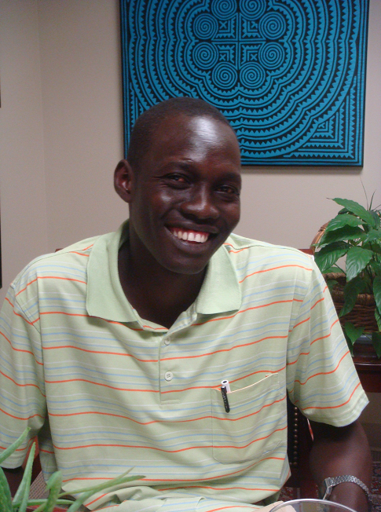
Christopher Gore: PhD program in Chemistry, University of Utah
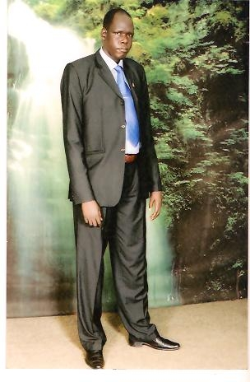
Albino Dar Gaw, MS program, Kampalla International University
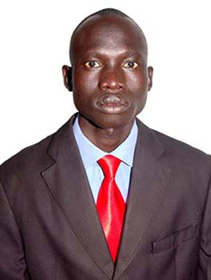
Hoth Tot Chany, Master’s program in Economics
Makerere University, Kampala, Uganda
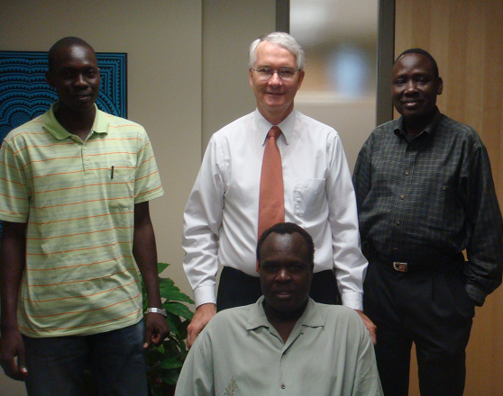
MADF President, Mawien Arik (seated). PhD candidate, Chris Gore (left), Legal Counsel Scott Jenkins (center) and Trustee Santino Bol (right)

